### Analysing Housing Prices in Metropolitan Areas of India

**Introduction:**

House price prediction in a metropolitan city in India is a valuable solution for potential home buyers, real estate agents, and investors. By leveraging historical sales data, property details, and location-specific information, a predictive model can accurately estimate house prices. The model's scalability, real-time updates, user-friendly interface, and transparency ensure it meets the needs of stakeholders. Integration capability, data privacy, and cost-effectiveness are also important considerations. By addressing these requirements, the prediction model provides reliable insights, empowering stakeholders to make informed decisions in the fast-paced real estate market.

**Objective:**

The objective of analysing housing prices in metropolitan areas of India is to gain insights into the trends, factors, and patterns that influence the real estate market in these urban centres. By conducting this analysis, we aim to understand the dynamics of housing prices and identify potential drivers for price fluctuations.

**Purpose:**

Analysing house prices in a metropolitan area using Tableau can provide valuable insights for various stakeholders, including real estate agents, property developers, investors, and homebuyers.

Understand the overall market trends and patterns in the metropolitan area. Use Tableau to create visualizations that show historical house price trends, average prices over time, and changes in property values.

Analyse the geographical distribution of house prices within the metropolitan area. Use maps and geographic visualizations in Tableau to show hotspots and areas with high and low property prices.

Help investors identify potentially profitable opportunities by analysing areas with high growth potential. Visualize data on house price appreciation, neighbourhood development, and other relevant factors.

**Conclusion & Future Scope**

Houses with best facilities in India. By analysing the number of bed rooms and Services provided, may somebody with the dilemma to buy or not buy his/her own houses based on price and best facilities.

It allows homebuyers to compare house prices across different neighborhoods or regions in the metropolitan area. Use filters and interactive visualizations in Tableau to facilitate this comparison.

**Screenshot of Brainstorming Map**

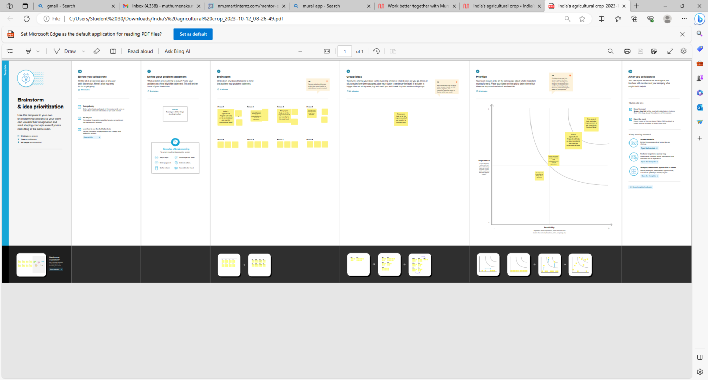

**Screenshot of Empathy Map**

